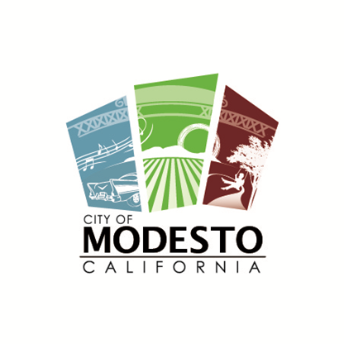
City of Modesto
Community and Economic Development Department
Building Safety and Neighborhood Preservation Division
1010 Tenth Street, Suite 3100
Modesto, CA 95354

Third Party Reviews

In order to provide expeditious service to developers, the City of Modesto allows plans to be submitted at any time prior to application of the building permit to one of Building Safety’s approved plan checking firms.

City review can be conducted after third party review or concurrently if Planning entitlements are in place

Applicant will contact third party directly

The developer/owner and designer proceed at their own risk without assurance that the project will be approved by any other division.

Building plan review fees will be negotiated with, and paid directly to, the third party

Plans will still need to be reviewed by other City divisions and/or departments

Building permit and inspection fees will be assessed and paid to the City of Modesto based on the scope of work. Additionally, all other fees will be paid as usual

In addition to plans required per the appropriate submittal form, applicant will provide Building Safety with two copies of plans stamped reviewed by the third party

Currently Approved Third Party Firms:

CSG Consultants  930 Fresno Street  Newman, CA 95360  209-862-9511  www.csgengr.com | Bureau Veritas North America, Inc  180 Promenade Circle, Suite 150  Sacramento, CA 95834  916-725-4200  www.us.bureaveritas.com
4Leaf, Inc  2126 Rheem Drive  Pleasanton, CA 94588  925-462-5959  www.4leafinc.com | Interwest Consulting Group  9300 W Stockton Blvd, Suite 105  Elk Grove, CA 95758  916-683-3340  www.interwestgrp.com

Developer/Owner___________________________________________ Date____________

Contractor_________________________________________________ Date____________

Revised 4/18/2018

